**Advance Excel Assignment 8**

**1. What do you mean by AutoComplete feature in Excel and what are the benefits of using this feature?**

Ans. AutoComplete helps you quickly insert functions and arguments while minimizing typing and syntax errors.

**2. Explain working with workbooks and working with cells.**

Ans.

Workbooks: A workbook is a file that contains one or more worksheets. It serves as the primary container for organizing and managing data in a spreadsheet application. Each workbook has its own unique name and can be saved independently.  
In Excel, for example, you can create a new workbook by launching the application, and it will automatically create a new, blank workbook. Workbooks can also be opened from existing files or templates. Within a workbook, you can add, rename, delete, and organize worksheets.

Cells: Cells are the individual units within a worksheet grid where you can enter, edit, and display data. Each cell is identified by a unique combination of its column letter and row number, such as A1, B3, C5, etc. Cells can contain different types of data, including numbers, text, dates, and formulas.  
Cells are the building blocks of a worksheet, and you can perform various operations on them.

**3. What is fill handle in Excel and why do we use it?**

Ans. You can quickly copy formulas into adjacent cells by using the fill handle. When you drag the handle to other cells, Excel will show different results for each cell.

**4. Give some examples of using the fill handle.**

Ans. 'Fill Handle' is a tool that you can use to autocomplete lists in Excel. For example, if you have to enter numbers 1 to 20 in cell A1:A20, instead of manually entering each number, you can simply enter the first two numbers and use the fill handle to do the rest.

**5. Describe flash fill and what the different ways to access the flash fill are.**

Ans. Flash Fill automatically fills your data when it senses a pattern. For example, you can use Flash Fill to separate first and last names from a single column, or combine first and last names from two different columns.

**6. Extract first name and last name from the mail id and then from the address column, extract the city, state, and pin code using the flash fill. Given below is an example of the columns you have to create. Paste the screenshot of what you have created using the flash fill command. Example: Mail Id, Address, First name, Last name, State, City, Pincode.**

Ans.

Extracted first name and last name using Flash fill.

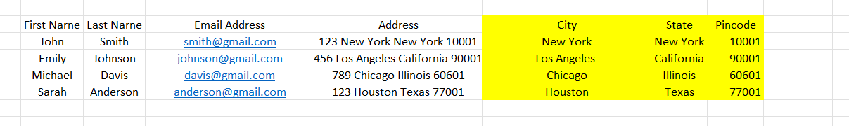

Extracted City, State & Pincode using Flash fill.